link figma: https://www.figma.com/make/eTJTfmsHVm8aVqdz2bfpPt/Create-new-project?fullscreen=1&t=T7a1Y40leS6FcGRE-
link github: https://github.com/thanhtrc3/QuanLyDanhMucVaChongChiDinhThuoc
hình ảnh jira:
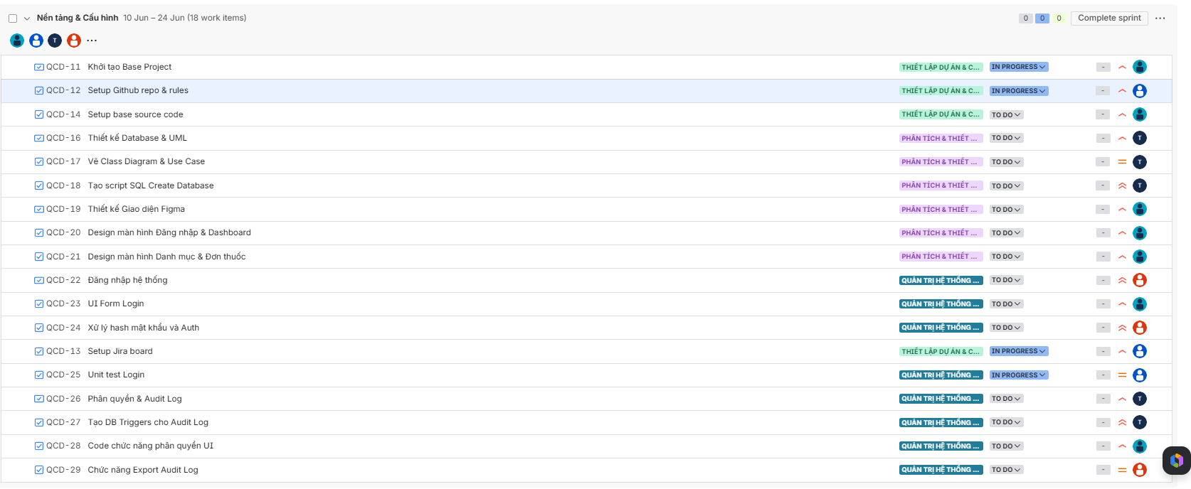
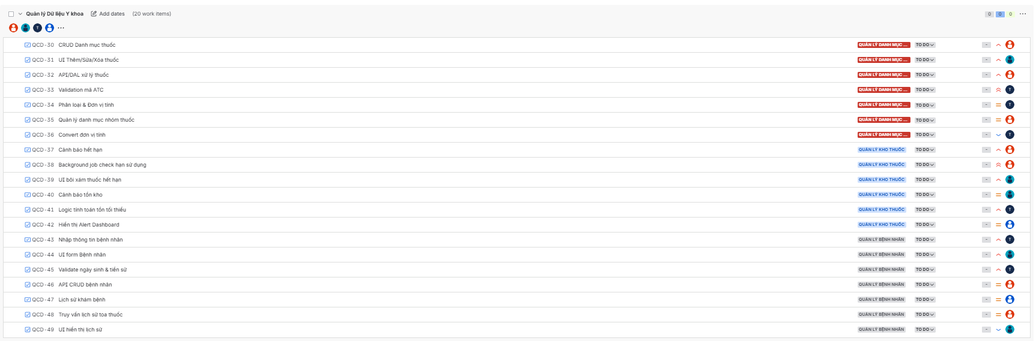

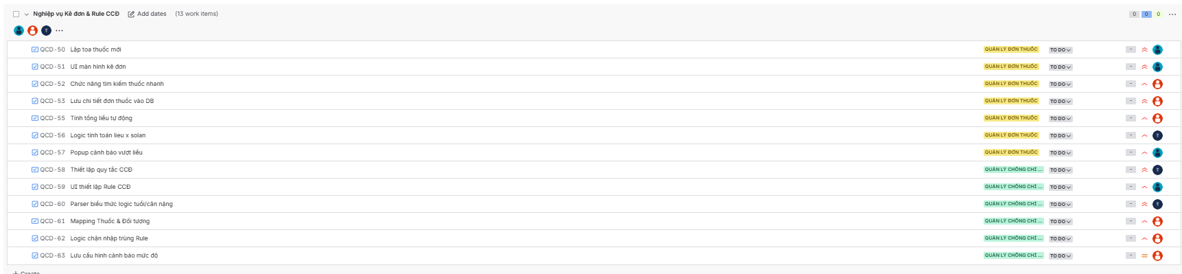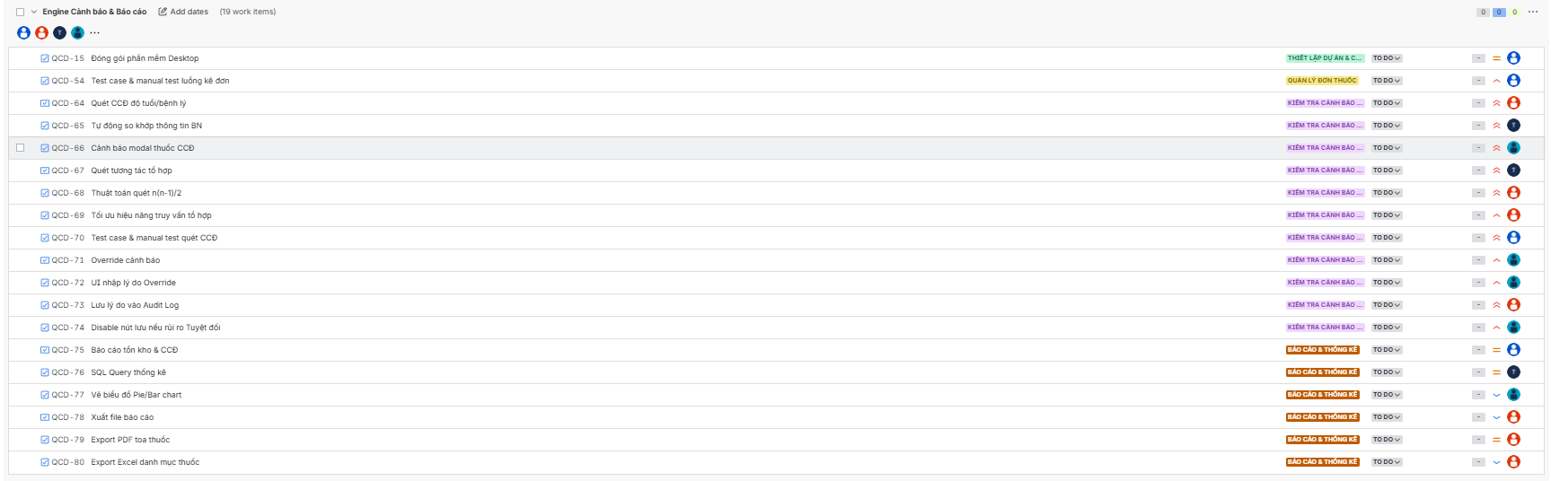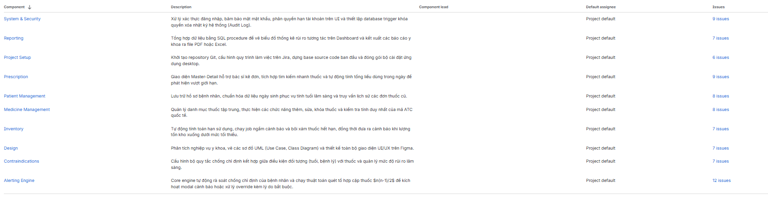
Diagram
